docker volume prune//remove stopped containers,unused volumes,networks,dangling images.
docker pull mysql
docker image inspect mysql //to check volume path
docker container run -d –name mysql -e MYSQL_ALLOW_EMPTY_PASSWORD=true mysql
docker container run -d –name mysql2 -e MYSQL_ALLOW_EMPTY_PASSWORD=true mysql
docker container rm -f mysql mysql2
docker volume ls//the 2 volumes are still there.but no name shown which make it hard to understand which one belongs to which container.so we will use named volume
docker container run -d –name mysql3 -e MYSQL_ALLOW_EMPTY_PASSWORD=true
-v mysql-db:/var/lib/mysql mysql
docker volume ls
Now it becomes easy to track.
****************************bind mount*********************************
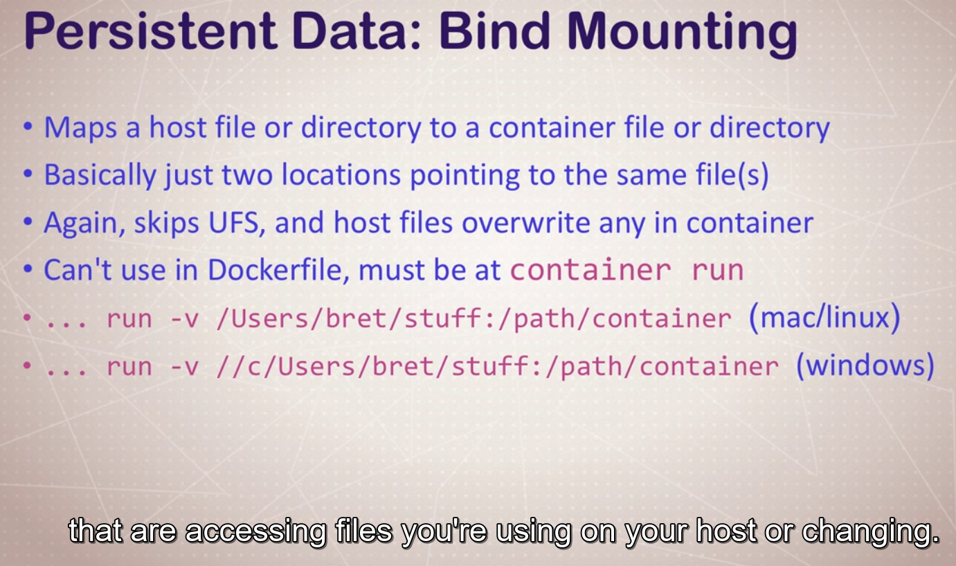
cd dockerfile-sample-2
ll
pcat Dockerfile
docker container run -d –name nginx -p 80:80 -v $(pwd):/usr/share/nginx/html nginx
//It will show our index.html not the defaultone.But if we run again without -v
docker container run -d –name nginx2 -p 8080:80 nginx
//localhost:8080 it will show default nginx index.html.
//So we can see that our custom one is living in that directory which can be monitored using port 80
Here is the details
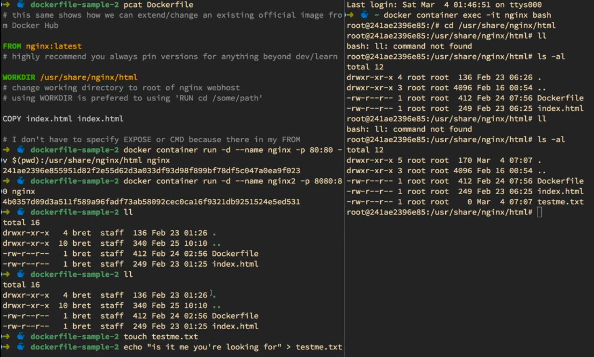
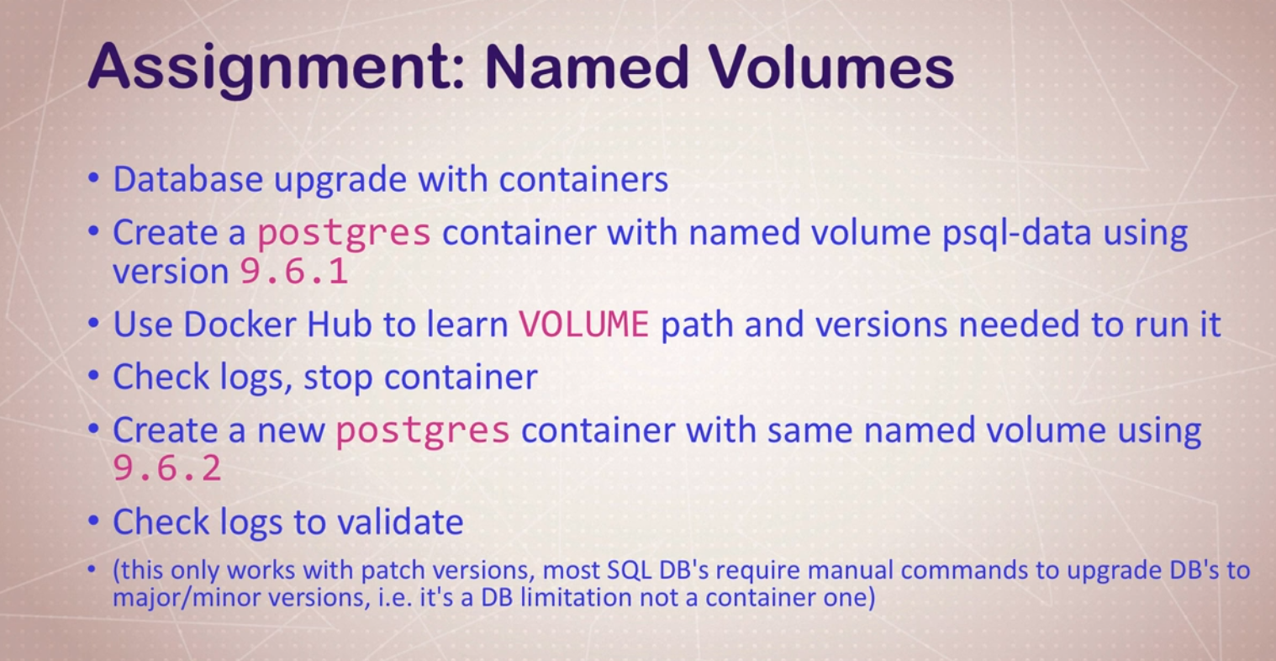
docker container run -d –name psql -v psql:/var/lib/postgresql/data postgres:9.6.1
docker container logs psql
docker container stop [id of psql]
docker container run -d –name psql2 -v psql:/var/lib/postgresql/data postgres:9.6.2
docker container logs psql2
docker container ls -a // we will see 2 container
docker volume ls //only one .so the assignment was successfully done.
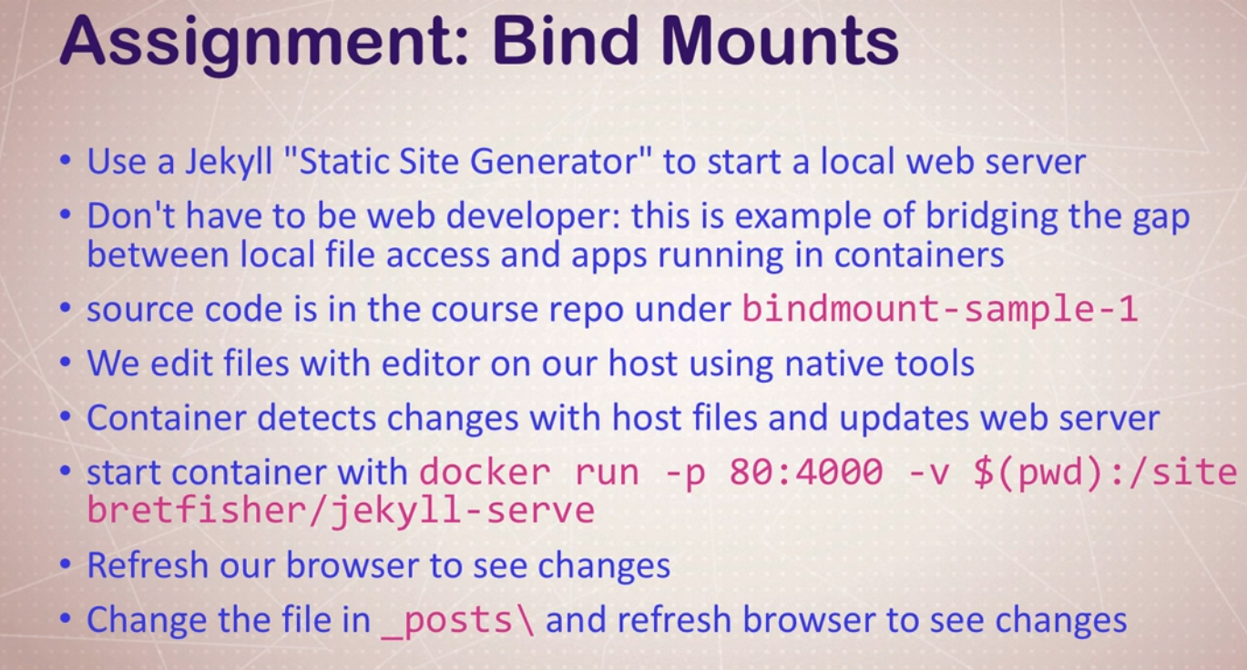
Answer is already given.just check if changing something reflects upon the page .

